

Webservices Implementation and Syndication Guide

Revised: 1/1/10
Version: V1.0
NHS Choices Syndication Team

Table of Contents

Introduction 3
Web Services Offered 3
Integrating Web Services 4
News Feed 4
News Topic List 4
News Article List 5
Find Services Feed 8
Services Search 8
Live Well Web Services 9
Topic 9
Groups 11
Articles Since 11
Health A-Z (Conditions) 12
A-Z 12
Articles Since 14
Common Health Questions 15
Tools 15
Appendix A: Find Services Elements 16
Appendix B: List of Find Service Types 16
Appendix C: Attribution 17
Appendix D: Example Sites 17
Appendix E: Representations 17
Appendix F: Reporting Requirements 18

Introduction

NHS Choices webservices feeds allow you to syndicate selected content from www.nhs.uk, and place it on your own website. This content will automatically update (when you run the service), meaning your content is constantly up-to-date. There are 5 areas currently available for syndication, as well as the option to syndicate video content, which will give you access to a range of video media on a range of topics, and interactive tools, such as a Healthy Eating self-assessment tool.

The five areas are:

- News
- Find Services
- Live Well
- Health A-Z (Conditions)
- Common Health Questions

In addition, content can be syndicated for use on mobile applications and devices; an example of this would be an application locating your nearest GP/Pharmacy/Hospital (based on your location).

Web Services Offered

The five areas will be covered in detail, with examples of how to access the content, and, where relevant, how to implement successfully. The Health A-Z and Live Well content is accessed via a different platform; eventually the entire range of feeds will be accessed via this method.

The five areas are as follows:
Accessed by username and password

News – this service provides access to all news topics and articles (see http://www.nhs.uk/News/Pages/NewsIndex.aspx)

Find Services – this service provides access to a range of services, either based on location or other specifiable criteria. For example, it could be integrated with GIS/mapping solutions to provide ‘Find my nearest…’ options for the end user (see http://www.nhs.uk/servicedirectories/Pages/ServiceSearch.aspx)

Common Health Questions – this service provides access to all Common Health Question topics (see http://www.nhs.uk/CHQ/Pages/home.aspx)

Accessed by API Key

Live Well – this service provides access to all Live Well topics and articles (see http://www.nhs.uk/livewell/Pages/Livewellhub.aspx). Access is via an API key rather than username and password

Health A-Z – this service is broken to 3 different areas; A-Z, Gender,and Subject. Access is via an API key rather than username and password

The Video and Tools services are also available, although integration and syndication of these services differ slightly to the feeds above.

Assistance with syndication

Should you require any assistance with syndicating content, please contact the Implementation Manager (Matt George) on 0207 9721538. For assistance with Videos, please contact the Video Syndication Manager (Golda Raphael) on 0207 9721762. You can also access our Partner Syndication pages, which provide assistance, forums and a place to discuss the Webservices – please see www.nhssyndication.org

Integrating Web Services

Implementing any or all of the feeds starts by getting access to the feeds themselves. You will have been sent a username and password that will allow you to access the webservice feeds. In the most part, accessing the content will require you to enter a URI, which will contain the username and password.

For example, in order to access the Diabetes news, the URI would be
http://www.nhs.uk/NHSCWS/News/NewsArticlesList.aspx?user=username&pwd=password&topic=Diabetes

Throughout this document, this format will be used. When accessing the services, ensure that the username and password are entered. All webfeeds, with the exception of Health A-Z and Live Well, are similarly accessed. See these sections for details on how to access them.

News Feed
News Web Services can return one of three sets of data, dependant on criteria. The three areas that can be accessed (in hierarchical order) are:

News Topic List – this will return all topics as they appear on www.nhs.uk. Access to this feed would be through

http://www.nhs.uk/nhscws/News/NewsTopicsList.aspx?user=username&pwd=password
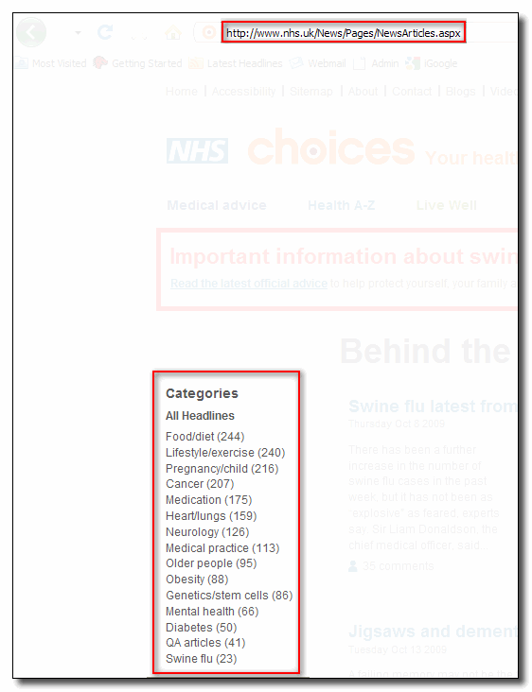
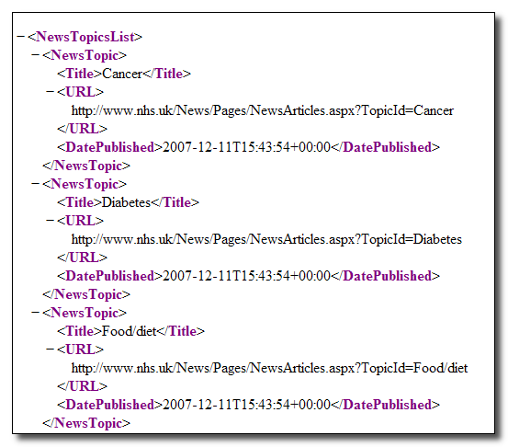
Figure 1: the relationship between the Categories on www.nhs.uk and the NewsTopicsList returned by the webservices feed

The required parameters and the results set (output) returned are:

NEWS TOPIC

Parameters | user (username, required), pwd (password, required)
EXAMPLE | http://www.nhs.uk/nhscws/News/NewsTopicsList.aspx?user=xxx&pwd=xxx
Results | Title (news topic title), URL, DatePublished

News Article List – this will return all news articles, news articles via topic, or an individual article. Access to these feeds would be through:

List Articles (all topics)
http://www.nhs.uk/NHSCWS/News/NewsArticlesList.aspx?user=username&pwd=password

A parameter can be added to filter by topic:

List Articles (by specific topic)
http://www.nhs.uk/NHSCWS/News/NewsArticlesList.aspx?user=userName&pwd=password&topic=topic

List Articles will bring back the first 10 articles that appear on http://www.nhs.uk/News/Pages/NewsIndex.aspx (see figure 2), regardless of topic. By default, the pagination is set to 10, displaying the first page. If a topic is introduced, the articles returned will be specific to this topic. In the example in figure 3, the topic ‘swine flu’ was appended to the URI, returning the first 3 articles (as the PageSize filter was set to 3).

The required parameters and the results set (output) returned are:
LIST ARTICLES (All topics)
Parameters | user (username, required), pwd (password, required), pageNumber (controls page being viewed, optional), pageSize (controls pagination)
EXAMPLE | http://www.nhs.uk/NHSCWS/News/NewsArticlesList.aspx?user=xxx&pwd=xxx&pageNumber=1
LIST ARTICLES (by specific topic)
Parameters | user (username, required), pwd (password, required), topic (specific topic for articles, optional), pageNumber (controls page being viewed, optional), pageSize (controls pagination)
EXAMPLE | http://www.nhs.uk/NHSCWS/News/NewsArticlesList.aspx?user=xxx&pwd=xxx&topic=diabetes  &pageNumber=1&pageSize=10
Results | EUID (unique article identifier), DateLine (date and time of publish), HeadLine (article headline), SlugLine (article summary), NewsItemRef (URL of article)

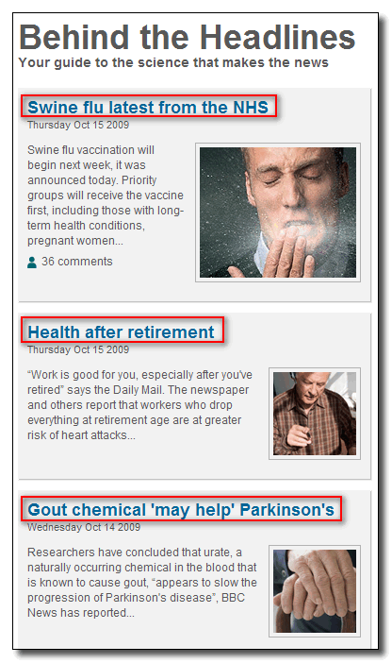
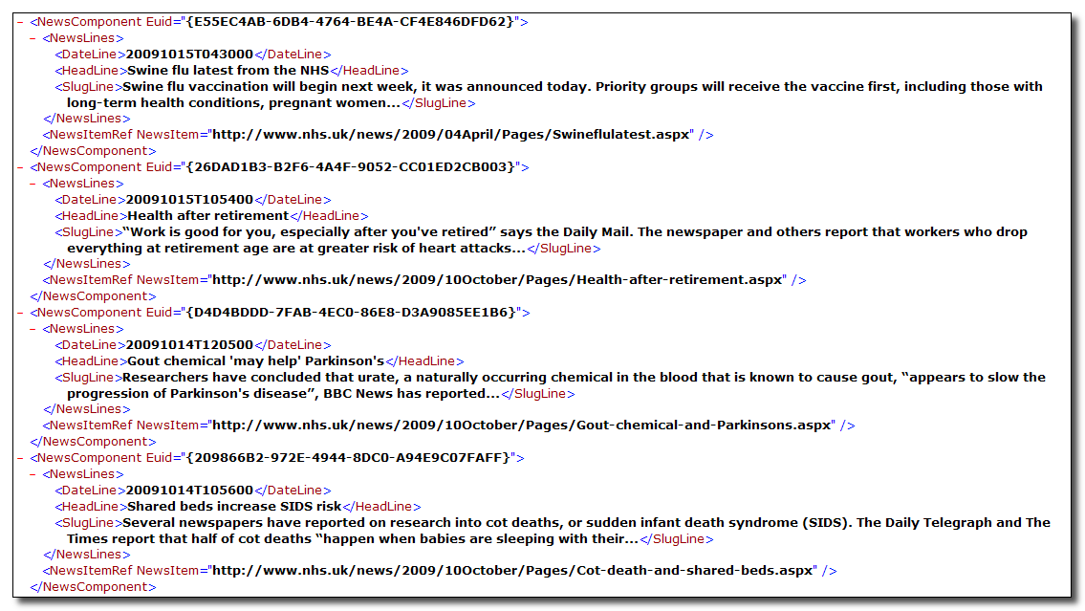

The web service request displayed here illustrates the relationship between the News headlines displayed on www.nhs.uk (left), and the data returned by the feed (above). The articles list is returned in NewsML; the opening tags in the returned XML deal with the identification and management of the content (such as creation date, language etc). The EUID tag identifies each individual article, and can be used to pull back the content on an individual basis (see below)
Figure 2: List Articles (all topics)
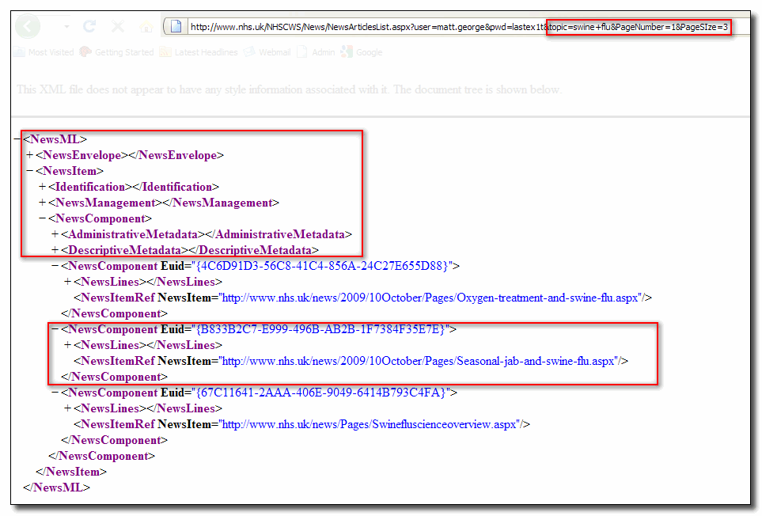
Single article (displaying EUID and location of original article)
These tags deal with identification of the content, any additional metadata tags (language, provider etc)
Filtered by Topic (Swine Flu), PageNumber (1) and PageSize (3). Displays 1st three articles on swine flu (see below)
Figure 3: Article level, filtered by topic and pagination. Articles identified by EUID
As demonstrated above, each article has its own identifier (EUID). This ID can be used to pull back individual articles.

List Articles (by unique identifier/article)
http://www.nhs.uk/NHSCWS/News/NewsArticle.aspx?user=userName&pwd=password&id={949368B6-1A9C-4F1C-920B-31D1FE15455A}

The required parameters and the results set (output) returned are:

LIST ARTICLES (by unique identifier)
Parameters | user (username, required), pwd (password, required), id (unique GUID of article)
EXAMPLE | http://www.nhs.uk/NHSCWS/News/NewsArticle.aspx?user=userName&pwd=password&id={xxx}
Results | The result set contains the complete article (in NewsML format); this results set includes elements such as ‘Heading’, ‘Quote1’ and ‘LinksToHeadlines’, which will be populated by headings, quotes and links respectively. All content, including images, sidebars and links will be contained within these elements, and can be formatted (using stylesheets) as required. For a detailed breakdown of element fields, types and descriptions see NHSChoicesWebServicesAPI_v1[1].12

Find Services Feed

Find Services allows you to search for services provided by service provider – for example, you might want to locate all GP surgeries in SW4. The results are driven by parameters, specified below. It is also possible to retrieve all service providers by type.

Services Search
Via this webservice, it is possible to return a filtered list of services, such as GPs, Hospitals, Dentists etc, by criteria; this criteria can take the form of a location, coordinates or an organisation name. The required criteria for this service are q, which denotes the location etc, and type, which denotes the service type to be returned. Access to these feeds would be through:

http://www.nhs.uk/NHSCWS/Services/ServicesSearch.aspx?user=userName&pwd=password
&q=location/organisation/etc&type=servicetype

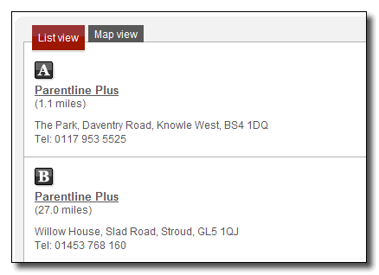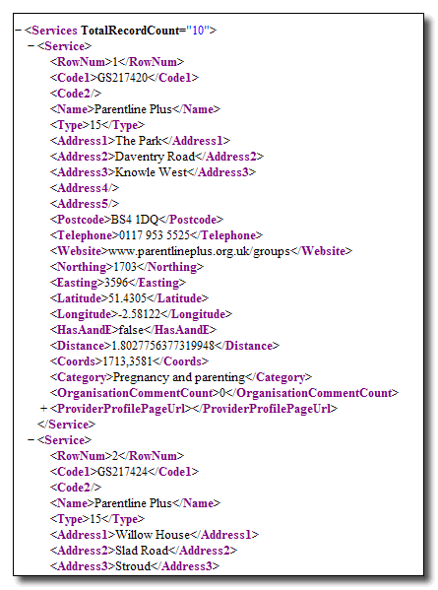
Figure 4: the relationship between service type on www.nhs.uk and the Service Search returned by the webservices feed

The required parameters and the results set (output) returned are:

SERVICES SEARCH
Parameters | user (username, required), pwd (password, required), q (location/postcode/organisation etc, required), type (service type, required). For a full list, see Appendix A
EXAMPLE | http://www.nhs.uk/NHSCWS/Services/ServicesSearch.aspx?user=xxx&pwd=xxx&q=London+Bridge&type=5
Results | The results set brings back information relating to the services, such as provider name, address details, website, distance from q, and so on. For a full list, see Appendix B
Note that when results are returned, the total record count is displayed at the top of the results, indicating the total number of records returned.

This service brings back location or organisation specific information, based on criteria entered.

Live Well Web Services

Live Well feeds are accessed differently to those encountered so far, as they sit on the newer v1 syndication platform. This platform is being developed to enable easier access to all feeds, and will be used across all services in the future.
Access is through an API key, which will have been supplied to you when your account was activated. To access the Live Well feeds, enter the following URI in to your browser:

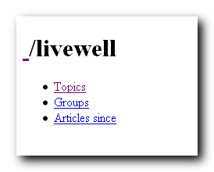
http://v1.syndication.nhschoices.nhs.uk/livewell?apikey={APIKEY}

The content is now accessible via a series of hyperlinks. Simply follow the links to gain access to the content required.
Figure 5: Live Well content accessed via one of three ways
The articles can be accessed in one of three ways:

Topic

Topic allows you to view all Live Well articles by topic. Once drilled down into, the individual articles relating to the topic will become available.
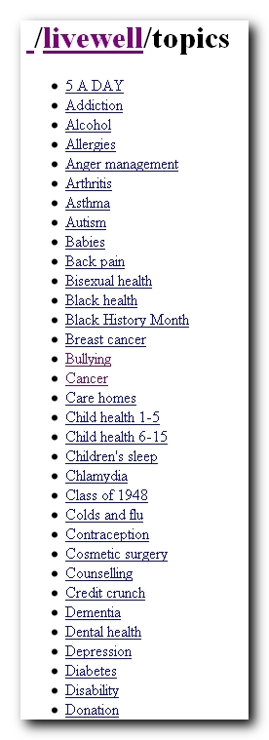
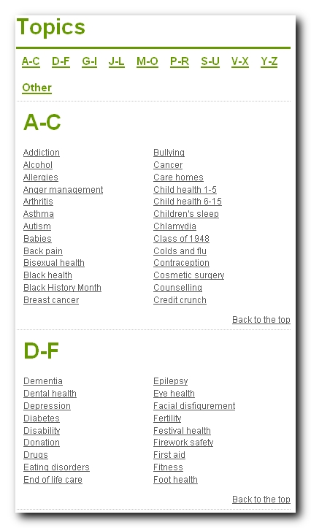
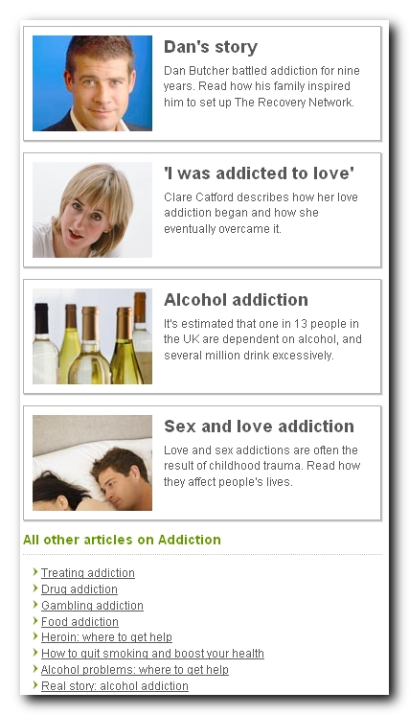
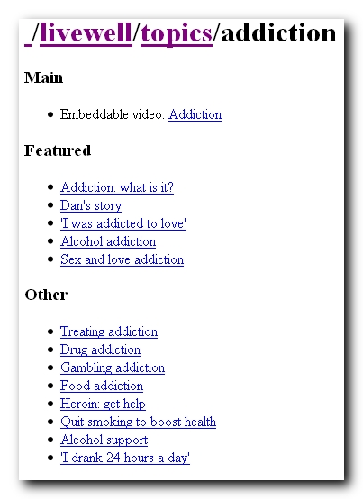
Figure 6: Live Well content accessed via one of three ways, illustrating relationship between Live Well Topics on www.nhs.uk and the Topics/Articles returned by the webservices feed

*

* Note: we do not syndicate any images apart from the body map used within Health A-Z (Conditions)

Once a topic/article has been selected, the content can be accessed in a variety of representations, allowing you to syndicate the content in a suitable manner. A full range of representations for each service is available at http://v1.syndication.nhschoices.nhs.uk/sitemap?apikey={APIKEY}

In general, you can select the content as:
- text/html
- application/xhtml+xml
- application/xml
- application/atom+xml
- application/rss+xml
Once you have chosen the representation you require, copying the URI will give you the feed. You can now implement this into your pages using server (asp/php) or client (javascript/iframe) side.
See Appendix E for further information regarding representation types.

Groups

Live Well articles can also be access via Groups, which essentially group topics together into relevant chunks. These groups mirror that on the NHS Choices website.

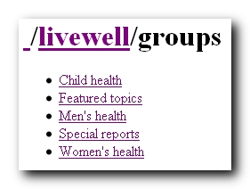
Figure 6: Live Well content accessed via one of three ways, illustrating relationship between Live Well Topics on www.nhs.uk and the Topics/Articles returned by the webservices feed
Once the groups and subgroups are accessed (by drilling down through the links), the groups revert to topics, at which point the feeds can be taken in the same way as described above.

Articles Since
It is possible to search and return a list of articles from a certain date. Once you have entered your dates (in the format dd/mm/yyyy), the list of articles added since that date will be returned in an rss feed format.

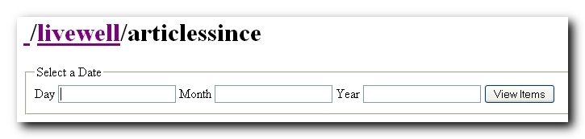
Figure 7: Articles Since search in Live Well

Health A-Z (Conditions)

The health A-Z pages contain information relating to all conditions within www.nhs.uk, and can be accessed in three different ways. As with Live Well, the conditions are accessed through use of an API key. The process for taking the feeds is identical to that described above.

A-Z

A-Z breaks down conditions by an alphabetical list. Once drilled down through, the particular condition is broken down by section, allowing integration of the full condition, or individual part. These parts vary from condition to condition, but generally follow a similar pattern (Introduction, Cause, Treatment and so on).
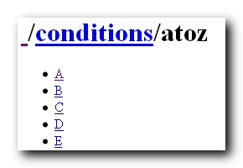
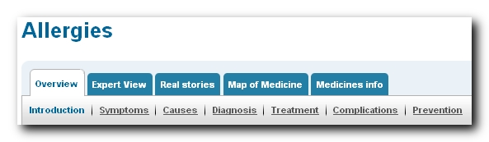
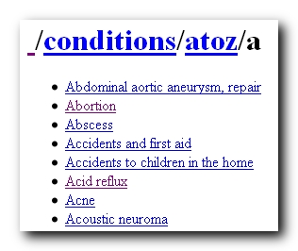
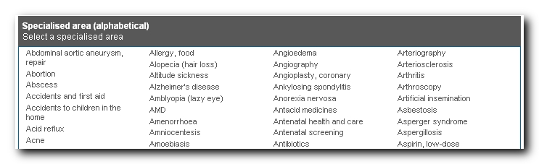
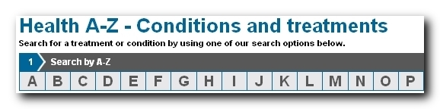
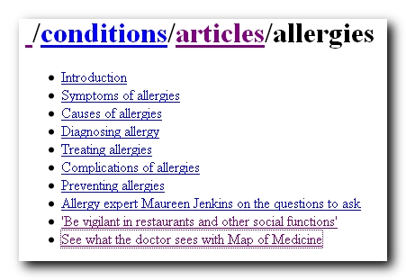
Figure 6: Relationship between Choices website and syndication, from top level down

Getting to the relevant section is as simple as clicking through the links. For example, to integrate the full content for allergies, the link would be:
http://v1.syndication.nhschoices.nhs.uk/conditions/articles/allergies?apikey={APIKEY}

To integrate the introduction from the allergies condition, the link would be:

http://v1.syndication.nhschoices.nhs.uk/conditions/articles/allergies/introduction?apikey={APIKEY}

Gender

Choosing gender allows you to access the full range of condition by body part (gender specific) or full body. Full body offers breakdown of conditions via major groups (blood, bones etc), whilst body part offers breakdown of conditions via body section (this may be more than one level). This mirrors the functionality of the main site, and comes complete with the requisite .gif files depicting the bodymap.

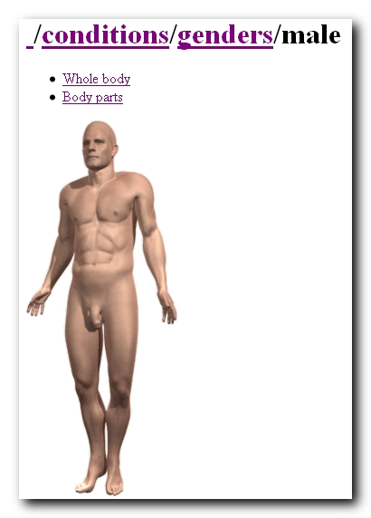
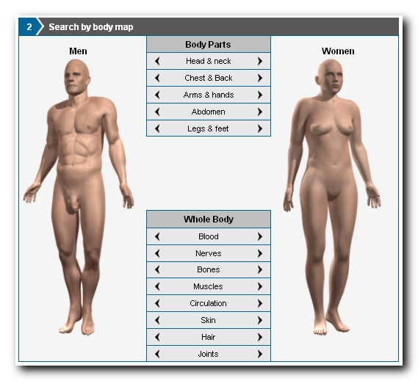

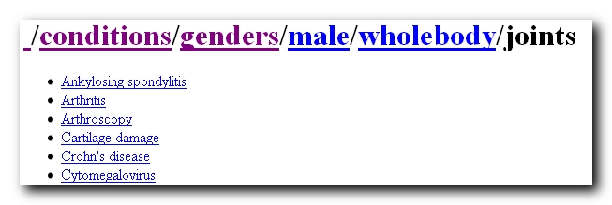
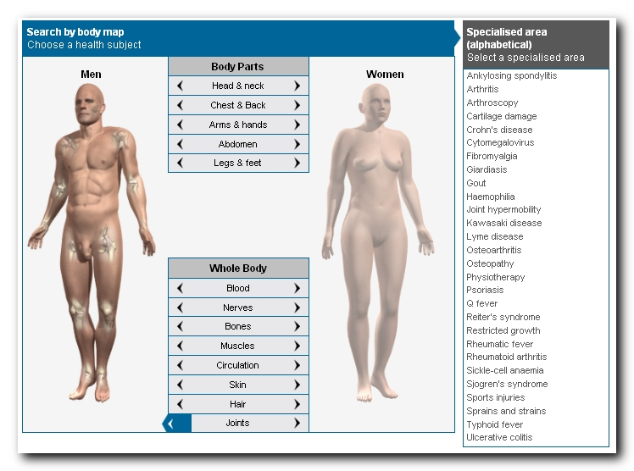
Figure 6: Relationship between Choices site, and the syndicated content, going through the levels and sublevels of conditions via gender

Again, content can be utilized by pointing direct to the URI. For example, to show the top level bodymap for male conditions (offering the choice between body part and whole body), the link would be:

http://v1.syndication.nhschoices.nhs.uk/conditions/genders/male?apikey={APIKEY}

And to show the conditions for male abdomen, the link would be:

http://v1.syndication.nhschoices.nhs.uk/conditions/genders/male/bodyparts/abdomen?apikey={APIKEY}

Subjects

Subjects allows you to specify condition via subject, as displayed on the Choices website.
As before, clicking through the links will get you to the condition.

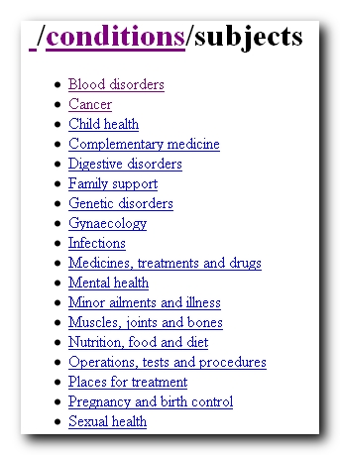
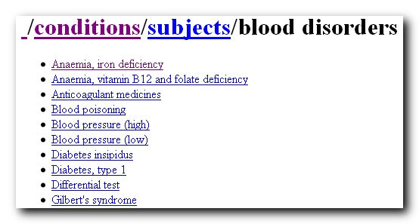
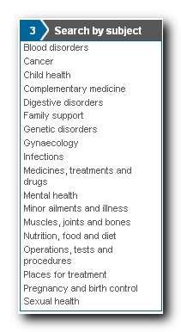

And as before, the process of syndicating content is as simple as using the URI server or client side.

For example, to access the subject blood disorders, the URI would be:

http://v1.syndication.nhschoices.nhs.uk/conditions/subjects/blood disorders?apikey={APIKEY}

Articles Since
It is possible to search and return a list of conditions from a certain date. Once you have entered your dates (in the format dd/mm/yyyy), the list of conditions added since that date will be returned in an rss feed format.

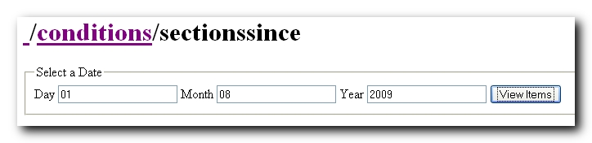
Figure 7: Sections Since search in Conditions

Common Health Questions

This webservice returns all the Common Health Questions from the NHS Choices website. Unlike other Webservices, it is not possible to select individual article or sections. Instead, the full list of questions is returned. The returned list can be filtered via pagination.

Common Health Questions
Parameters | user (username, required), pwd (password, required), pageNumber (controls page being viewed, optional), pageSize (controls pagination)
EXAMPLE | http://www.nhs.uk/NHSCWS/News/NewsArticlesList.aspx?user=xxx&pwd=xxx&pageNumber=1
COMMON HEALTH QUESTIONS
Parameters | user (username, required), pwd (password, required), pageNumber (controls page being viewed, optional), pageSize (controls pagination)
EXAMPLE | http://www.nhs.uk/NHSCWS/News/NewsArticlesList.aspx?user=xxx&pwd=xxx&topic=diabetes  &pageNumber=1&pageSize=10
Results | ArticleID (unique article identifier), Title, URL, Description, PublishingPageContent (entire CHQ content wrapped in CDATA), Modified (last modified date)

The URL for this service is http://www.nhs.uk/nhscws/Common/chq.aspx?user=userName&pwd=password

Tools
Tools are standalone flash-based files, which are designed to provide the end user with a more interactive experience. For further information on installing tools, see <Tools doc>. Currently, around half of the tools are available for syndication. For a full list of these, a breakdown of how to install the tools, and guidance on sizing, please speak to Matt George (matt.george@dh.gsi.gov.uk).

Appendix A: Find Services Elements

Element | Description
RowNum | Serial number of the service provider in the result set
Code1 | The combination of this field and ‘Code2’ uniquely identifies a service provider.
Code2 | The combination of this field and ‘Code1’ uniquely identifies a service provider.
Name | Name of the service provider.
Type | Type of the service provider. For all possible values, refer to the description of ‘type’ parameter in the list of parameters above.
Address1, Address2, Address3, Address4, Address5, Postcode | Part of service provider’s address.
Telephone | Telephone of the service provider.
Website | Website of the service provider.
Northing, Easting | Northing and Easting of the service provider.
Latitude and Longitude | Latitude and Longitude of the service provider.
HasAandE | Indicates whether service provider offers A&E services.
Distance | Distance of the service provider in miles from the location against which the search has been performed.
ProviderProfilePageUrl | URL of the profile page of the service provider on NHS Choices website.

Appendix B: List of Find Service Types

1 | GPs
2 | Dentists
3 | Pharmacists
4 | Opticians
5 | Hospitals
7 | Walk-in centres
9 | Stop-smoking services
10 | NHS trusts
11 | Sexual health services
12 | DISABLED (Maternity units)
13 | Sport and fitness services
15 | Parenting & Childcare services
17 | Alcohol services
19 | Services for carers
20 | Renal Services
21 | Minor injuries units
22 | Mental health services
23 | Breast cancer screening
24 | Support for independent living
26 | Memory problems
27 | Termination of pregnancy (abortion) clinics
28 | Foot services
29 | Diabetes clinics
30 | Asthma clinics
31 | Midwifery teams
32 | Community clinics

Appendix C: Attribution

As stated in the Service Level Agreement or Memorandum of Understanding signed, all content syndicated from NHS Choices must be properly attributed. The logo should link back to the NHS Choices website (www.nhs.uk), and where possible, directly to the host page. The official logo is provided below; it must not be altered in any way.



Appendix D: Example Sites

http://www.solihull.nhs.uk/Your-services - example of how Find Services can be implemented

http://living.aol.co.uk/health/healthy-living - example of how Health A-Z can be implemented

http://www.extra-care.org/nhs.php - example of how News Web Services can be implemented

https://www.check-kit.org.uk/news/?id=90202644-99E3-46B4-B4C6-5F99900A3EBF & https://www.check-kit.org.uk/news/?id=19882D20-5F0B-4BE8-A77F-C6B21DD1E8FF – examples of how Live Well can be implemented

http://www.tiscali.co.uk/lifestyle/healthfitness/ - overall integration example

http://pepperfox.co.uk/nhs.news - example of content on a mobile device (only suitable for mobile device viewing)

Appendix E: Representations

The representations available when using content supplied by the API Key are specified below. Not every representation is available for all content – for a detailed list of what representations are available for certain content, see http://v1.syndication.nhschoices.nhs.uk/sitemap?apikey={APIKEY}

text/html
This will display content in text format, with no tags. Visual formatting will be applied
application/xhtml+xml
Displays content in xhtml/xml format, with formatting tags applied
application/xml
Displays content as xml. If your browser has RSS support, the content will render in the default reader (as with atom and rss feeds below). Linking or opening the content outside of the browser will provide you with the pure xml content
application/atom+xml
Displays content as atom (xml). As with xml and rss, if your browser has inbuilt RSS support, this content will render in this reader. For more information on atom, see http://en.wikipedia.org/wiki/Atom_%28standard%29
application/rss+xml
Displays content as rss (xml). For further information, see http://en.wikipedia.org/wiki/RSS

Appendix F: Reporting Requirements

If you are using either of the feeds that require the API key, you will need to provide us with a monthly report on traffic to any pages containing NHS Choices syndicated content. This will need to be supplied to us in .xls/.csv format, detailing number of views for all pages syndicating content, at the beginning of each month (covering the previous month’s activity). This is in accordance with the reporting requirements specified in your Terms and Conditions

Pagination can be controlled by appending &PageNumber=xxx&PageSIze=xxx to a string

